Volume 22 Issue 3 www.lakemitchellhobo.org Third Quarter 2017

Don’t Miss This Opportunity!
HOBO Editor Needed NOW!

Since January 2015, it has been my challenge and pleasure to serve as editor for Lake Mitchell HOBO Newsletter. As editor, I have become acquainted with people of all ages, from many different areas, and with wildly varied interests, but all sharing at least one point in common-our beautiful Lake Mitchell. I have thoroughly enjoyed getting to know each and every one, and in doing so, helping in a small way to continue the tradition of maintaining a strong HOBO community on our lake. I think community building is important, and I am happy to have been a small part of that effort.
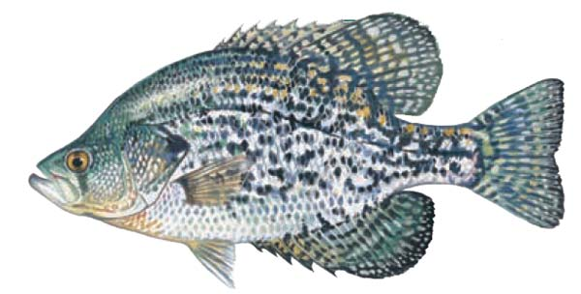
As we make our way into 2017, having acquired a job and a beautiful grandson (pictured at right) who needs a grandma to take care of him every other week, it is time for a change. This will be my last issue of Lake Mitchell HOBO Newsletter. I know that there is someone in the Lake Mitchell community who, like me, is willing and at least a bit able to take on the job of keeping the Lake Mitchell community connected and informed through continuing production of HOBO News. Marie Green will train and support a new editor as she has done with me. Work should begin on Issue 4 in September. Please contact Marie (marieandhugh@gmail.com) or our HOBO President Scott Phillips (wsphillips2@gmail.com) today to let them know that you are willing to serve.
Michael Alan Barlow

The Crappie Thumper

Spring is over and the Crappie are getting fat! Summer is here and the Crappie are in their summer pattern. Now the fish are either following bait fish in open water or may be found in cover. Types of cover might be submerged wood or fishing docks.

Today I will discuss fishing docks using a technique called "shooting docks." Basically you pull your jig back and sling it under docks instead of casting. This varied casting method is both fun and challenging to the best of fishermen...be warned...it is easy to get a jig in your hand!

In preparing tackle, you will need about a six-foot rod and a spinning reel. I use one of my crappie rods with a fast lip. The reel is lined with a six pound, Hi-Vis line. The jig is usually a 1/16 or 1/32 ounce, with different colored plastic grubs. I prefer the 1/32 most often, because it sinks slower. Experiment with different grubs to see which one skips the best.

As you develop your technique for "shooting docks," the most important thing to be stressed is safety. Safety is all about how you hold the jig. I hold it by the head, with the hook facing away from my hand. Holding the jig by the bend in the hook is also safer. The key is not hooking yourself!

“Shooting Docks” step by step:

*Let off 3-4 feet of line
*Hold the jig between your thumb and index finger
*Pull the jig down, bending the rod and keeping the jig under the rod
*For accuracy, it is best to have the rod parallel to the water
*Time the release of the jig and line
Timing is critical; this will come with practice. I practice at my dock and still can't always get the jig as deep under a dock as I would like.
*Position the boat about 6-10 feet away from the dock and "shoot the dock," then engage the reel.
*Keeping a semi tight line, watch the line intently, waiting for the line to twitch. You may expect to see about half of the strikes and feel the other half.
"Shooting docks" is another way to add fun and excitement to the sport of Crappie fishing!!

In closing, take a kid fishing if you have the opportunity. I was lucky enough to take a kid and his granddaddy fishing last week. It was his first fishing trip! I do not know who was most excited as we caught fish!

Have fun on the water. As you are "shooting docks" be respectful of dock owners and skip the docks, which are being used by homeowners.

Keep what you can eat and release the rest!

Lake Mitchell Trivia
Courtesy of Alabama Power Company Shorelines website

In 1921 the Federal Power Commission granted Alabama Power Company a license to construct a dam across the Coosa River near Clanton, downstream from Lay Lake, at a location called Duncan's Riffle. The dam and lake are named for former Alabama Power Company President James Mitchell. An internationally known electrical engineer, Mitchell came to Alabama in 1911 to survey its potential for hydroelectric power development. Construction of Mitchell Dam, Alabama Power Company's second hydroelectric plant, was completed in 1923 and it has been busy producing hydropower ever since.
Mitchell Dam is the second oldest of 14 Alabama Power Company hydroelectric generating plants. The dam was named for James Mitchell, Alabama Power president from 1912 to 1920.
Located on the Coosa River near Verbena, the dam straddles the Chilton and Coosa County line. A unique feature of the new powerhouse, which was completed in 1985, is a 1,140-foot floating trash boom, which deflects trash from the powerhouse intakes.

Mitchell Reservoir Facts:
Elevation above sea level: 312 feet
Area: 5,850 acres
Shoreline: 147 miles
Length: 14 miles
Maximum depth at dam: 90 feet
Area of watershed draining into reservoir: 9,827 square miles.

Lake Mitchell HOBO 2017 Scholarship Winners

Tessa Thompson
Jadon Downs

Lake Mitchell HOBO is pleased to announce that Tessa Thompson and Jadon Downs are this year’s scholarship winners. Each winner was awarded $2,000.

Tessa lived on Lake Mitchell as a young child. She graduated from Verbena High School and will be attending Judson College. Tessa will be majoring in pre-veterinary, and plans to become a horse chiropractor.

Jadon is a 2017 graduate of Chilton County High School. He will be attending Auburn University where he will seek a double major in Computer Science & Software Engineering and Business/Marketing. Jadon is an Eagle Scout. His project was with Raleigh’s Place, a home and summer camp for foster children.

This is the ninth year that Lake Mitchell has awarded scholarships to students from Chilton or Coosa County.
Thanks to all of you who have helped support our scholarship by your donations, taking part in the Poker Run, participating in our photo contests to create our Lake Mitchell calendars, and by purchasing those calendars.
This project provides a way of being good neighbors to those who live in the counties that border the beautiful lake we share.

Lake Mitchell Area Representatives

Area | Area Name | Representative | Phone
1A | The Ridge | Chan Aldridge  Chan.aldridge@gmail.com | 334-303-0202
1B | Alaga Landing | Bobby Lewis  docx2@mindspring.com | 205-212-1020  205-901-8307
1C | Blue Creek | Wesley Pinson  bluecreekmarina@outlook.com | 205-755-1198  205-217-366-
2 | Blue to Cargile | Jim & Johnye Woodrow  ajwking@aol.com | 205-425-9431  205-913-0122
3 | Cargile South | Dan Murchison  DanMurchison@gmail.com  Janet Pandzik  pandzikj@gmail.com | 205-408-7445  205-441-1959  205-224-0432
4 | Cargile North | Connie Hampton connie28fan@yahoo.com  Susan Orr  soriii@bellsouth.net | 205-755-6344  334-312-6131  205-613-3491
5 | Cargile to Bird | Peggy Bullard  pnsbullard@gmail.com | 205 -755-9514
6 | Bird Creek | Leslie Miles  lesliemiles0@gmail.com | 205-755-6432  205-612-2172
7 | Bird to Walnut | Becki & Mau McCallum  beckmau@gmail.com | 205 -755-5334
8 | Walnut SW | Beau Battaglia  beauredsox@yahoo.com  Jim & Linda O’Rear  orearjl@gmail.com | 504-909-6990  251-327-0136
9 | Walnut Creek Peninsula | Betty & Joel Elam  Betty687@aol.com | 205-807-9056  205 -755-2775
10 | Cove and Mountain | Roxanne Martin  roxypmartin@gmail.com | 205-821-0863
11A  11B | Mountain to Lay Dam – Chilton side  Lay Dam to Hatchet – Coosa side | VACANT-  Please Volunteer for Area 11A  VACANT-  Please Volunteer for Area 11B
12 | Upper Hatchet and Weogufka | VACANT-  Please Volunteer for Area 12
13A | East Pennamotley | Jim & Wathan Hand  jmhand@centurylink.net | 256-377-1153
13B | West Pennamotley | Richard & Wendy Cruse  wendycruse@gmail.com | 205-253-8298
14 | Hatchet to Big Airplane | Eric & Rose Green  rosegreenlake14@yahoo.com | 205-492-7151
15 | Airplane/Finger to Big Y Slough | Tommy Carpenter  rtcriver@gmail.com | 256-377-1046  205-586-1749
16 | Big Y to Mitchell Dam | Nan & David Spivey  davidaspivey@gmail.com  nanspivey@gmail.com | 256-377-1178  205-492-0375

Area Representative Reports:

Area 5-Cargile to Bird Peggy Bullard
The lake has been busy this year since early April and it will get even busier as the summer has just begun. I encourage everyone to become familiar with the boating laws and be cautious and courteous while on the lake. It has been brought to my attention that many are disturbed by loud music coming from boats while they are just wanting to chill on their decks and relax. We learned a long time ago that music on the boat was heard louder by those on the shoreline than those riding in the vessel. Therefore we usually only played our radio while the boat was docked at our pier. We enjoyed music while we worked on the boat or dock or relaxed lakeside. If you enjoy it while you are riding please respect those who are here just to relax and get away from the noise of the world for a short time. This can hold true if your neighbor’s house is in close proximity to yours. Everyone doesn’t have the same taste in music as we do so we should respect that and play it at a level that does not disturb others.
My heart grieves me to have to tell you we lost another dear friend in our area. Leona Crabtree went home to be with her Lord and Savior on May 28th. Many may not have known her and her husband Bob Crabtree because they were a quiet and gentle couple. Quiet people do not get much recognition but I can tell you they were a couple which showed much hospitality and would help you out in any way they could. Leona could make the best homemade biscuits ever. They owned the cabin just two doors north of me and Sonny and we were invited to share their table more than once. When they were able they participated in HOBO cleanups, fish habitat and other events. Leona and Bob loved Lake Mitchell and that love has been transferred to their children. Their son Don and his family and their daughter Lela all enjoy it as much as Bob and Leona did. Maybe even more. Bob delights in seeing his children and grandchildren enjoying their place here on Lake Mitchell. Pray for Bob and family as they make adjustments to live life without their loved one. They are able to rejoice that they have many sweet memories of Leona and many of those include time on Lake Mitchell.
Be safe on the water; send in your HOBO membership dues if you have not. Remember to call or email me if you have questions or concerns. If I cannot help you I’ll do my best to locate someone who can. Enjoy your summer.

Area 6 – Bird Creek
Farewell from Leslie Miles
Hey everybody,
Want all of you to know that I have passed the baton of being area 6 representative to Troy and Tina Crocker. They will serve our area and all of Lake Mitchell well. I have truly enjoyed my time and been so honored being a part of this fabulous group!! God Bless you all!
Welcoming Troy and Tina Crocker
Greetings from beautiful Bird Creek! Recently Leslie Miles asked Tina and I if we would be willing to take over as area 6/Bird Creek representatives. We gladly accepted her offer and look forward to serving our area and the entire Lake Mitchell Community.
Bird Creek and Lake Mitchell have greatly benefited from the selfless volunteerism of Leslie & Steve Miles for many years. Special thanks to Leslie for all of her time and efforts invested in making our community a better place. She has left big flippers to fill… we’ll do our best! Thanks again Leslie, We love you and appreciate you!
Who are the Crocker’s?
My first encounter with Lake Mitchell was in 1968. My grandfather brought us down to Mimosa Point for tent camping and crappie fishing. In the years to follow, we would move our basecamp over to Barrett’s Fish Camp. My brother and I would actually spend our spring breaks staying in one of the rooms at Barrett’s that had bunk beds and a hot plate. Those were certainly more simple times!!!
As our family matured and our boys went to college, Tina and I decided we needed to try full time lake life! It only made sense to go back to where I started!! We have been full time Lake Mitchell residents since June 2012. We have lived on Bird Creek since August of 2013.
We look forward to serving Bird Creek and Lake Mitchell for many years to come.
Thank you again Leslie for allowing Tina and I to serve.

Area 9- Walnut Creek Peninsula
Joel and Betty Elam

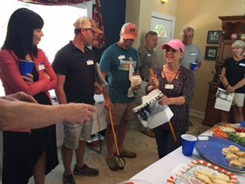
Summer has arrived and the lake has become alive again. It is so nice to see old friends that we have not seen for some time. As reported in our last article, we had a neighbor get together during the Memorial Day weekend. There were about thirty people who attended the celebration with food and fun for all. Many owners attended their first meeting and got to meet many new neighbors. During the meeting we discussed items of interest to our area and set up several committees to work on projects. I would like to thank all our friends for bringing food and attending this meeting.

Area 10 – Cove/Mountain Branch Doug and Roxanne Martin
Summer has arrived and the lake is beginning to get busy. Please be courteous and consider your neighbor and other boaters on the lake.
Our area has had several changes; Bill Knowles, Rick Shrader and Johnnie Slayton long-time residents of Cove Branch have passed and will be missed greatly.
We are so excited that Larry and Nancy Waldron are building their full time home on Lake Mitchell! We look forward to having them here very soon. Misty and Burry Haggard and their two girls will be joining our lake neighborhood. So happy to have them!
We hope to have an area party so we can all get to know our lake neighbors better.
Call us if we can be of assistance to you. Be safe and we will see you on the lake.

Area 13B – West Pennamotley Richard & Wendy Cruse
In Pennemotley it has been quiet except for the rain. And hammers and saws.

The rains have been of deluge proportion at times and to say that the winds have been blustery is to quote ‘Pooh too glibly. I saw a torrent of wind sweep down the slough one day last week that turned every leaf over and shook it vigorously, slowly working its way down the banks toward the thick grasses at the end. Even the geese stayed put. I saw trees twist and branches fall. As is said, Mother Nature is clearly a force to be reckoned with.

With that in mind I want everyone to check your porches, docks, and boathouses with the aim of securing everything that is lose lest it blow into Mitchell and become the subject of a Renew Our Rivers’ volunteer’s early morning efforts. Please tie down or lock up fun noodles, plastic floaties, tow-behinds, etc. With the winds that I have seen none of them are safe. I have pulled plastic chairs (not mine) out of the lake more than once and they are now secured to their dock. I have rescued—to the trash—numerous fun noodles. I have even pulled in two separate boathouse doors with a canoe, yes, I said ‘doors’—neither of which the owner was aware was missing. If you can lose boathouse doors in a storm than a chair can certainly blow off even if it might not have before.

And, after seeing the trees lurch from side to side dropping large, dead branches on my deck, I have been looking around for any more ‘widow makers’ and knocking them down before they can drop on me unexpectedly.

Regarding wildlife, I have seen some water moccasins, gray & white herons, geese, and ducks on the lake so far this season. A couple of turkeys and light colored deer on the road in but not as many as during the winter. Snakes are cunning, and yes, they do swim (and I have seen one swim under a neighbor’s boathouse doors before), so please check out your boathouse carefully especially if opening it for the first time this year. I get some wasps in my boathouse so I take a can of Raid down with me—snakes do not like it either.

Lastly, I want to say how much everyone enjoyed the picnic at Higgins Ferry this year. It is always good to be able to share the afternoon with so many fun people!

Rushton Revisited
By Chip Gates, Lake Mitchell HOBO Historian

William W. Wadsworth, as you may recall from an earlier article, was largely responsible for the founding the town of Rushton. Wadsworth, who later became known as the “Timber King of Alabama”, was born Oct. 17, 1841, near Prattville. He served as a scout and sharpshooter in the 21st Alabama Infantry during the Civil War. Wadsworth received multiple wounds throughout the war, including losing a finger in one skirmish. In 1865 in North Carolina he was shot through the body, the bullet passing near his heart, while another round shattered his left elbow, disabling him for life. Nevertheless, he survived the war and went into agriculture and the sawmill business. The mill he built at Rushton, where Blue Creek flowed into the Coosa River, became one of the largest in the state. It is reported there was narrow gauge rail line that was used to bring timber out of the woods and down to the mill. A second, standard gauge line, took finished products to market via a connection with the Louisville & Nashville Railroad, which was then known as the South & North Alabama Railroad.

William Wadsworth was not content with just his sawmill at Rushton. He maintained a commissary there, as well as at the town that bore his name. He also started a pottery works at Wadsworth and served as the town’s postmaster for 23 years. Wadsworth died in November 1913, and is buried in a church cemetery there. You can find his resting place by taking Hwy. 31 South from Verbena, then left onto Hwy. 143 S. towards Deatsville & Wetumpka. When you reach the intersection with Autauga Co. Rd. 68, the church will be on your left.

Back to our little town, in 1903 Rushton had its own U.S. Post Office. Having a post office back then literally put your town on the map. A 2-cent stamp was usually sufficient for general mail, but if you needed to correspond with someone overseas, you had to hand over to the postmaster a Liberty head nickel or 5 Indian head pennies. By the way, the name of this latter coin is actually a misnomer. According to Whitman’s “Guide Book of United States Coins”, the person represented was not a Native American but Miss Liberty wearing a headdress. However you paid, five cents was far cheaper than taking it there yourself. Plus it allowed for more time on the job at the Blue Creek Lumber sawmill, or farming, mining, or hunting and fishing along the as yet untamed river.

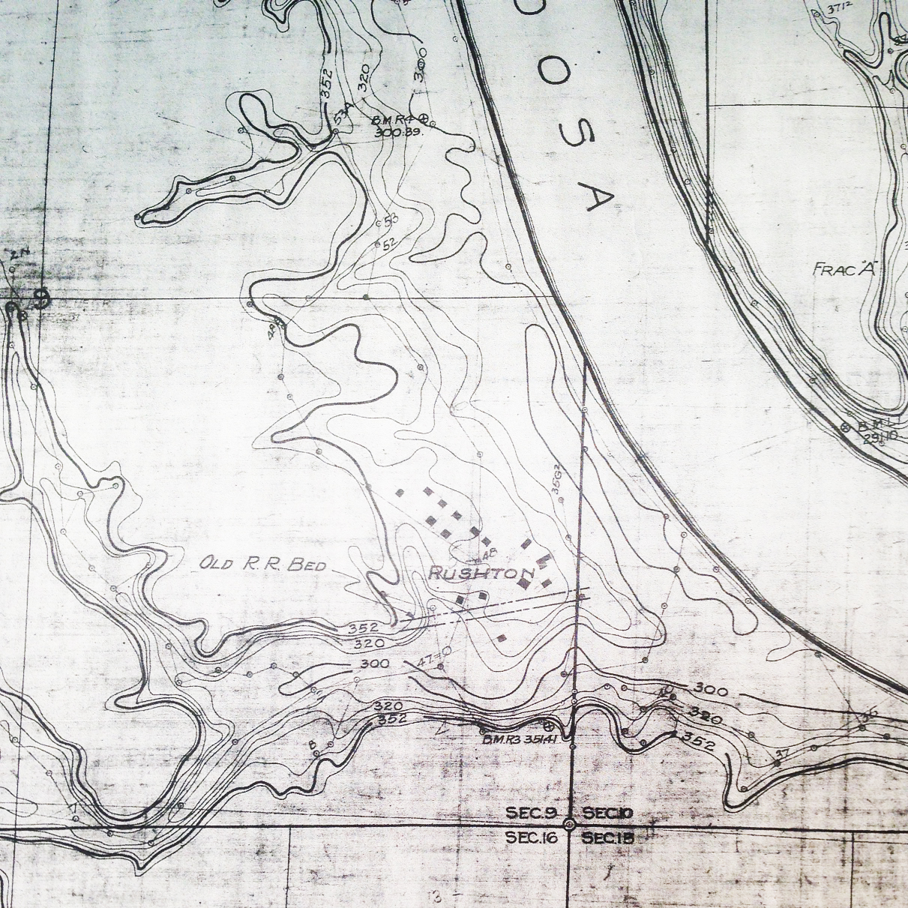
This last item was found on the genealogytrails.com website under Chilton County Military Data. At the beginning of the Civil War and at the age of 17, William B. Jones went to the community of Chestnut Creek and enlisted in Company B of the 1st Alabama Cavalry. Like Wm. Wadsworth, William Jones survived the war, and the 1907 Census of Confederate Veterans listed him as a resident of Rushton. In 1925 a Confederate Pensioners list showed the now octogenarian Mr. Jones living in Clanton. This move may have been brought on because of his age, but most assuredly it would have happened after the completion of Mitchell Dam and the submergence of Rushton in 1923.

The map is from May, 1919, and is entitled Duncan’s Riffle Development, Topography of Flooded Area. The solid boxes are structures that will have to be removed, as they are below the darker 352’ contour line. Today this corresponds with the full pool line, which in actuality is about 311 feet above sea level. Also note the parallel lines that indicate the “Old R.R. Bed”, which hugged the northern side of Blue Creek. Those of you familiar with the southern part of the lake will recognize the narrow gap that now leads to Blue Creek Marina. Original map courtesy of George Jackins

Lake Mitchell H.O.B.O. Calendars
By Melissa Nannini, Lake Mitchell Calendar Coordinator

We need your help to make sure that the 2018 HOBO Calendar goes on sale November 17, 2017 at our Annual HOBO Meeting! Calendar proceeds will help to fund scholarships for two deserving Coosa and Chilton County High School seniors. Dust off your cameras and start snapping! We will select a photo for each month as well as a cover photo. Our goal is to provide a fresh reminder of Lake Mitchell’s beauty, peacefulness, wildlife, traditions, people, and plain old fun times for each month of the year. Please send your pictures!
Email your pictures to Melissa.nannini@gmail.com.

P.O. Box 1324
Clanton, Alabama 35046 PAID Permit 12
Change Service Requested Birmingham, AL

Lake Mitchell H.O.B.O. Membership Application
Annual Dues  Required  $25 | Fireworks Donation  $ | Fireboat  Donation  $ |  | Scholarship  Donation  $ |  | In Memory/Honor  Name_____________________________________  $
Optional Purchase  Boathouse Sign $20____ |  | Optional Purchase  HOBO Photo Calendar $15_____ |  |  |  | Optional Purchase  Additional Phonebook $10___
Name: |  |  |  |  | Check  One: Renewal New Member
Home Mailing
Address:

Lake 911  Address: |  |  |  |  |  |  | Lake Area:
Email:

Home Phone: |  |  | Lake Phone: |  |  | Cell Phone
Detach and mail completed form along with your check to: Lake Mitchell H.O.B.O., PO Box 1324, Clanton, Al 35046

