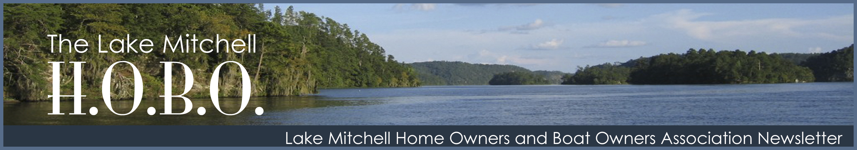
Volume 21 Issue 3 www.lakemitchellhobo.org Third Quarter 2016

June 4, 2016
A Big Day On Lake Mitchell!
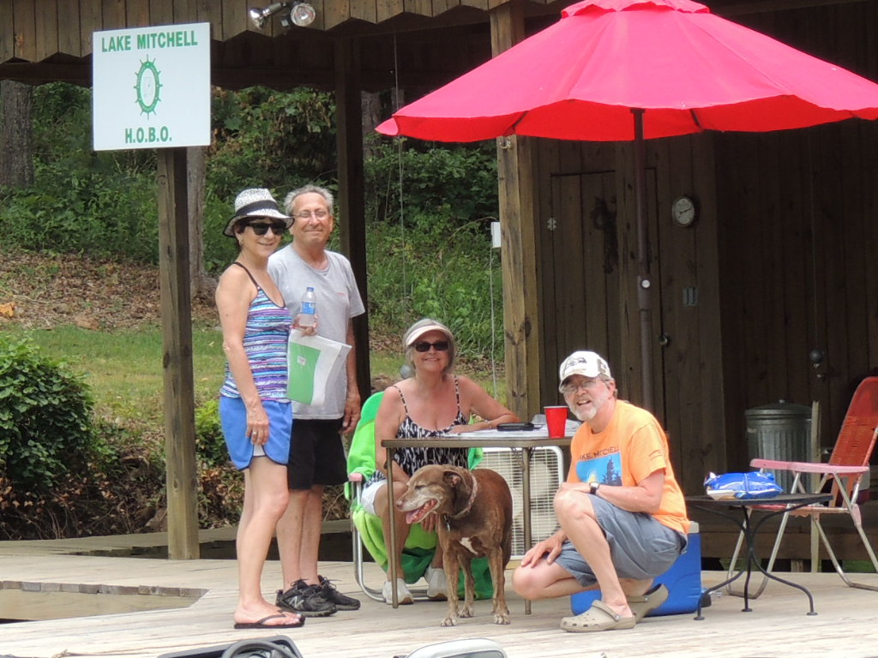
By Rebecca Beaty

June 4, 2016 was a big day on Lake Mitchell. The day started out busy, as boats and folks of all ages came to Higgins Ferry to sign in and pick up packets for the 2nd Annual Poker Run. The packets contained a score sheet, a map, and written directions to the eight dealers’ piers. Participants traveled from pier to pier on the lake to draw a card from each dealer. The dealers recorded the card drawn and signed off on each participant’s score sheet, then recorded the card again on the dealer sheet. At a designated time, all players chose the top 5 cards for their best hand and returned to Higgins Ferry. The judges checked each sheet to identify the participant holding the best five-card hand. This year’s winner was Stephanie Helms from Montevallo.

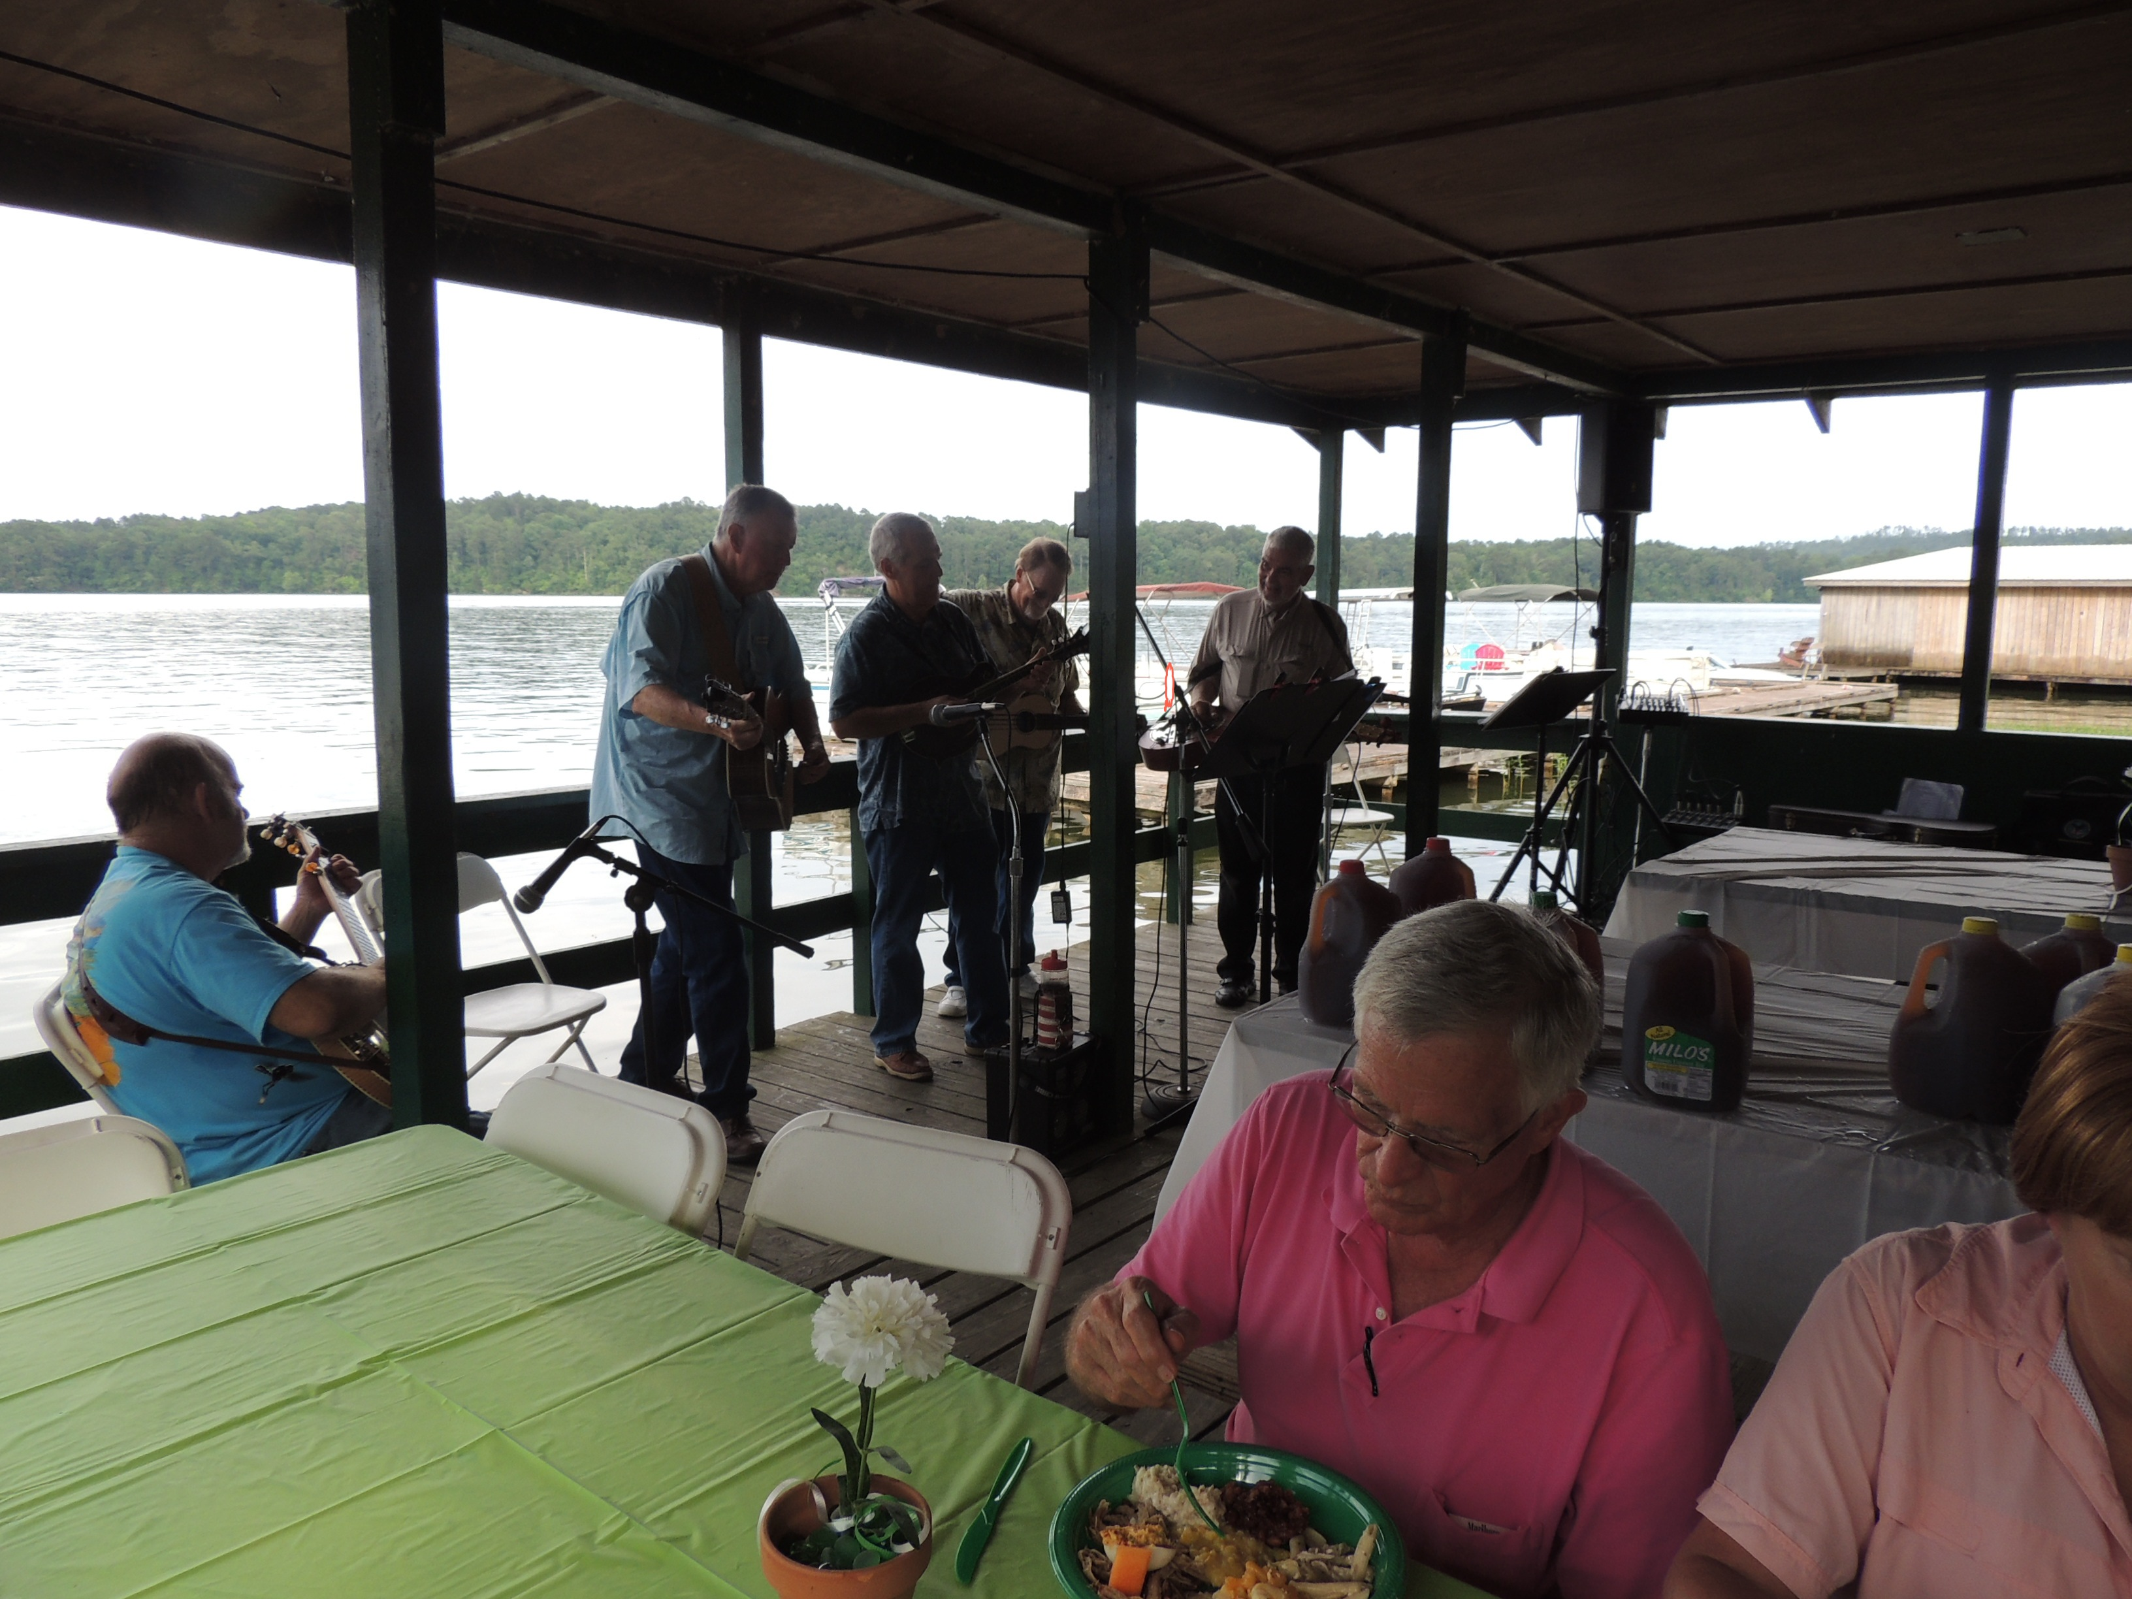
The grand prizewinner for the day received a portion of the cash proceeds raised through entry fees. Thanks to businesses and friends donating door prizes, no participant left empty handed! Participants, dealers, and committee members all had a great time.

At 4:30 that afternoon a big crowd gathered for the HOBO Annual Picnic. The band was great, the food was delicious, and everybody had a great time visiting with each other. Thanks to Jim & Johnye Woodrow for all the hard work they did pulling the picnic together.

The proceeds from the Poker Run benefit the Lake Mitchell HOBO Scholarship Fund. This event raised $750 toward next year’s scholarships! The scholarships are awarded to highly qualified students in Chilton and/or Coosa County. Funding for the scholarships also come from donations and the sale of Lake Mitchell calendars. Donations are welcome and are tax deductible. Send them to Lake Mitchell HOBO, PO Box 1324, Clanton, AL 35046.
Poker Run dealers were John & Kathy Redd, Pete & Julie Bernier, Scott & Gay Phillips, Phil & Betsy Ward, Alan & Melissa Nannini, Jim & Wathan Hand, Dianna & Dave Cassens, and Tom & Ann Brock.

Scholarship/Poker Run Committee members were Nancy Piccolo, Rebecca Beaty, Rose Green, Nan Spivey, Steve Miles, and Lee Poe.

A big THANK YOU to these sponsors from Lake Mitchell HOBO Scholarship Committee!

San Marcos Authentic Mexican Restaurante | Main Street Café”
Wal-Mart | Hollywood Nails
Wiley and Josie’s | Cakes and Candy
Bertolone Italian Café’ | Show Room Liquidators
B’s Market | Baugh Ford
Clanton Laundry | Brenda’s Barber Shop
Crystal’s Barber Shop | B B’s Bake Shop
CVS | Tractor Supply Company
Nellie and Bobby Austin | Trendy Chic Boutique
Bar-D | Sav Mor Associated Grocers
BMiller Art and Design | Mor Lyn Jewelry Store
Troy and Tina Crocker | Lake Mitchell HOBO
Pizza Hut

Did you know….? Part 2
Some snippets, plus some longer tales

By Chip Gates, H.O.B.O. Historian

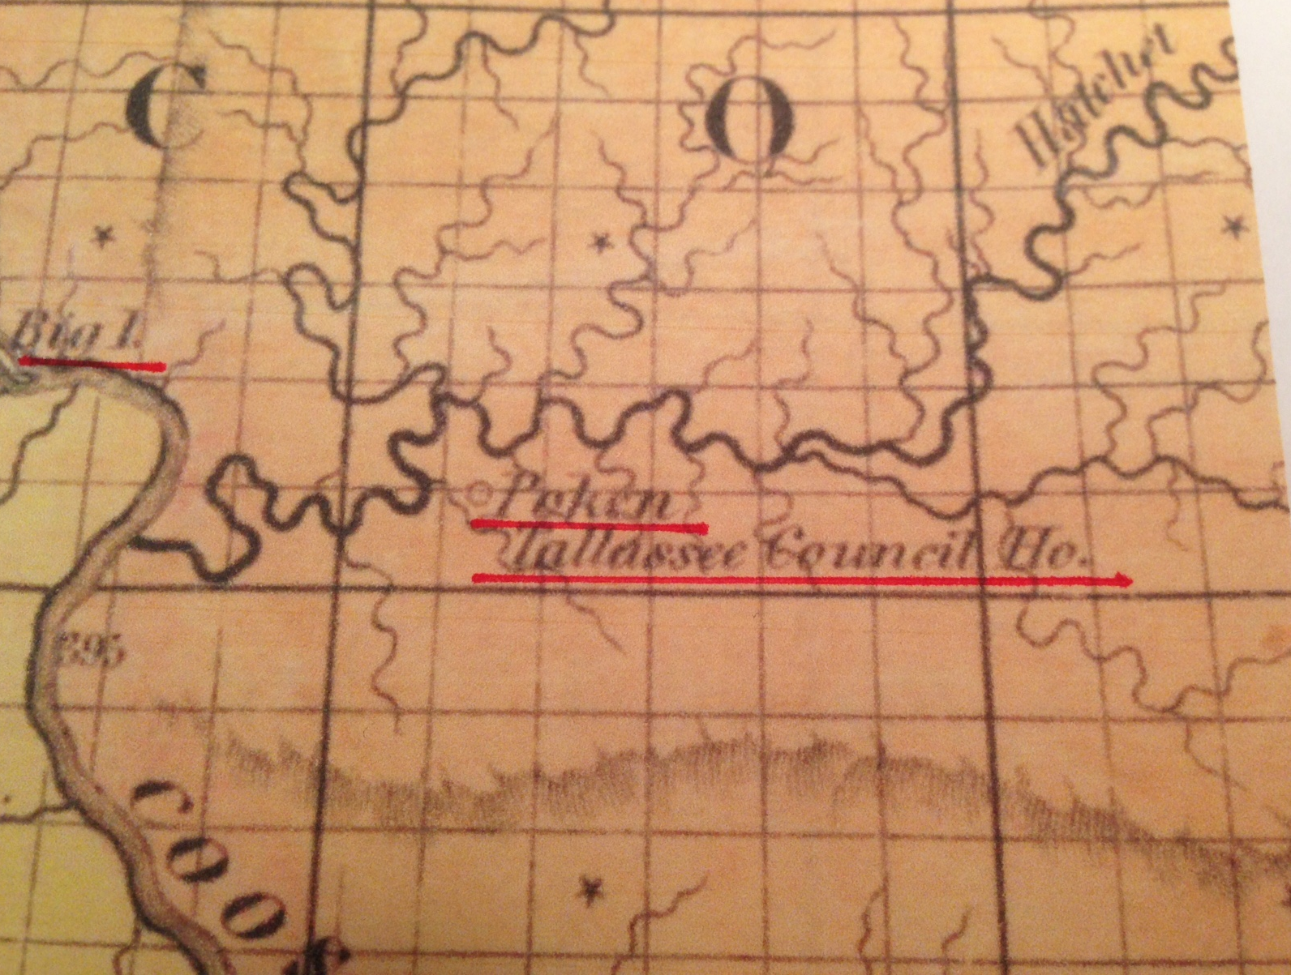

To start us off, one of our members offered a correction and an intriguing addition to one of the snippets that was in the 2nd quarter 2016 newsletter. Ed Clapp III (area 5) explained the formation and extent of Baker County with the following: In 1820, not long after the state was formed (12/14/1819), the northeastern portion of Bibb County reached the Shelby County line and included that which is now the town of Jemison. Some 49 years later on 12/30/1868, Baker County was formed from parts of Bibb (the eastern portion), Shelby, Autauga, and a small portion of Perry counties. Ed recognized the error in the earlier story because his mother’s family was from the Jemison area, and all their records, dating from the early 1800’s, had Bibb County on them. Furthermore, in looking up some old records, Ed found some amusement in the subsequent name change from Baker to Chilton County. From Wikipedia, we learn Baker County’s namesake, Alfred Baker, founded Clanton in 1868, naming it in honor of Confederate Brigadier General James H. Clanton. Clanton was incorporated on April 23, 1873, with Baker being elected its first mayor. This is not surprising, as The Central Alabama Genealogy website (www.alagenealogy.com) says Baker owned practically all of what is now Clanton. However, on 12/17/1874 the county’s name was subsequently changed to Chilton, in honor of Judge Wm. Parish Chilton, who died in 1871.

According to Ed, the folks around Clanton decided Mr. Baker was a little too chummy with the northern carpetbaggers, and petitioned the state legislature to rename the county after the state’s former Chief Justice. Justice Chilton never lived in the county that came to bear his name, but those that did back then were apparently more comfortable with his name than Baker’s. And from the “What if” department, think about this: If Baker had remained the county’s name, and that is where you obtain your car tags, the license plates would start with a 5 instead of 14. Don’t worry, my Coosa County friends. Your tags would still begin with a double deuce.

Did you know that prior to the 1958 completion of the Hwy. 22 bridge, in order to cross the river you would leave Hwy. 22, go south about a third of a mile and board a ferry? In the late 19th and early part of the 20th century this was known as Knights Ferry. Our Ed Clapp III (area 5) remembers when he was a 10 year old and his grandfather took he and his brothers to ride this ferry the last day it was in operation. Ed said they must have crossed the river 10 times that day. Afterwards his grandfather took the boys up to the Mims ferry and they rode it at least twice. What 10-year-old boy wouldn’t have good memories of a day like that!

When the Hwy. 22 bridge was built, the deep cut through the rock on the Coosa County side exposed the minerals actinolite-tremolite, gneiss and hornblende. Caution: Dust from asbestiform varieties of actinolite and tremolite can cause serious and irreversible lung disease when inhaled. Rock hounds should be careful and avoid creating or inhaling the dust.

Staying in the neighborhood but much earlier, in 1900 the Coosa County community of Knights had a post office, though it apparently didn’t serve many constituents. This is based on the annual salary its postmaster, J.M. Wyatt, received, which was $50.97. Back across the river in Chilton County, the postmaster of Burwell, W.N. Pierce, that same year took in $67.78. Burwell, you say? Well, today if you turn off Hwy. 22 and head north towards The Ridge or Mitchell Dam, you would drive right through it. Assuming it was still there, of course. And remember Dollar, just up Weogufka Creek and around the bend from Fixico? Postmaster J.H. Warnick no doubt had to supplement his meager yearly earnings of $19.47. Perhaps Mr. Warnick worked in one of the nearby mines when not handling the mail. Finally, just for reference sake, in 1900 these postmasters fared somewhat better financially: James G. Downs at Cooper earned $121.67, Francis A. Gulledge down in Verbena got $383.15, while at the big post office in Clanton Joseph B. Downs pulled in a whopping $792.28.

Before the turn of the 20th century there was a community named Enid located on the north side of Cargile Creek, between what is now Pumphouse Slough and the river. From Wikipedia comes this – Enid is a female given name, its Middle Welsh origin meaning purity. Somewhat refreshing isn’t it, that some of Chilton County’s water is drawn from a slough in this very same area? As late as 1949, Enid appeared on the General Highway Map of Chilton County, although on this particular map it was shown due north of the back end of Pumphouse Slough. So who was she, this 19th century girl or woman named Enid, for which the community was named?

A newer version of the General Hwy. Map of Chilton County, printed in 1965, no longer shows Enid, but it has these additions: Between Yellowleaf Creek and Mims Ferry is Traywick’s Fish Camp, the boy scout’s Camp Arrowhead is shown just below the mouth of Bird Creek, and Dixie’s New Fish Camp appears in the somewhat circular slough that is south through a land gap towards the back end of Cargile Creek.

Travelling many moons back in time we come upon the Indian village Pakan-Tallahassee. This village has been described as being in two locations: on the west side of Hatchet Creek within four miles of the river, and on both sides of the Coosa River at its confluence with that same creek. Pakana, a variation of Pakan, is a Creek word for peach, a fruit the local Indians first obtained from the Spanish. Pakana Tallahassee means Old Peach Town. Now wouldn’t it be something if the Creek Indians also chose a peach queen each year? As for the Spanish, there is a map that traces DeSoto’s route south into Alabama in 1540. In 1918 the Alabama Anthropological Society postulated that DeSoto and company crossed the upper reaches of Hatchet Creek in Coosa County somewhere between the 21st and 29th of August. However, in 1928 a Mr. J.Y. Brame claimed that during this same 1540 late summer timeframe DeSoto was much closer to the river, crossing Hatchet roughly 5 miles upstream of its mouth. The settlement where Brame believes DeSoto spent the night on Hatchet Creek was at the time called Itaba. Could Itaba have later become Pakan-Tallahassee? Wherever he stayed, with the coming of the lake, any DeSoto Slept Here signs have long since disappeared.

John LaTourrette with Colton & Co. put out a map way back in 1837 that contained some interesting bits of information. One of these concerned House’s Island (now submerged, between Higgins Ferry and Walnut Creek), which back then was called Big Island. Another was a notation regarding the location of Poken Tallassee Council House, a Creek Indian gathering spot. On LaTourrette’s map it was shown about ½ mile due south of the mouth of Weogufka Creek, which looking at a modern day map would put it just above the mouth of Bee Branch. However, this historic place has also been shown just east of Pennamotley East (area 13A), near present-day Mimosa Point Road. Just plain Poken (without the Tallassee Council House notation) appears on a number of late 19th century maps, and most place it on the south side of Hatchet Creek, about halfway between Pennamotley and Weogufka Creeks. So I’ll leave you with this thought: Poken and Pakana, Pakan Tallahassee and Poken Tallassee. Very similar, aren’t they? Perhaps all are one in the same, but in different locations at different times.

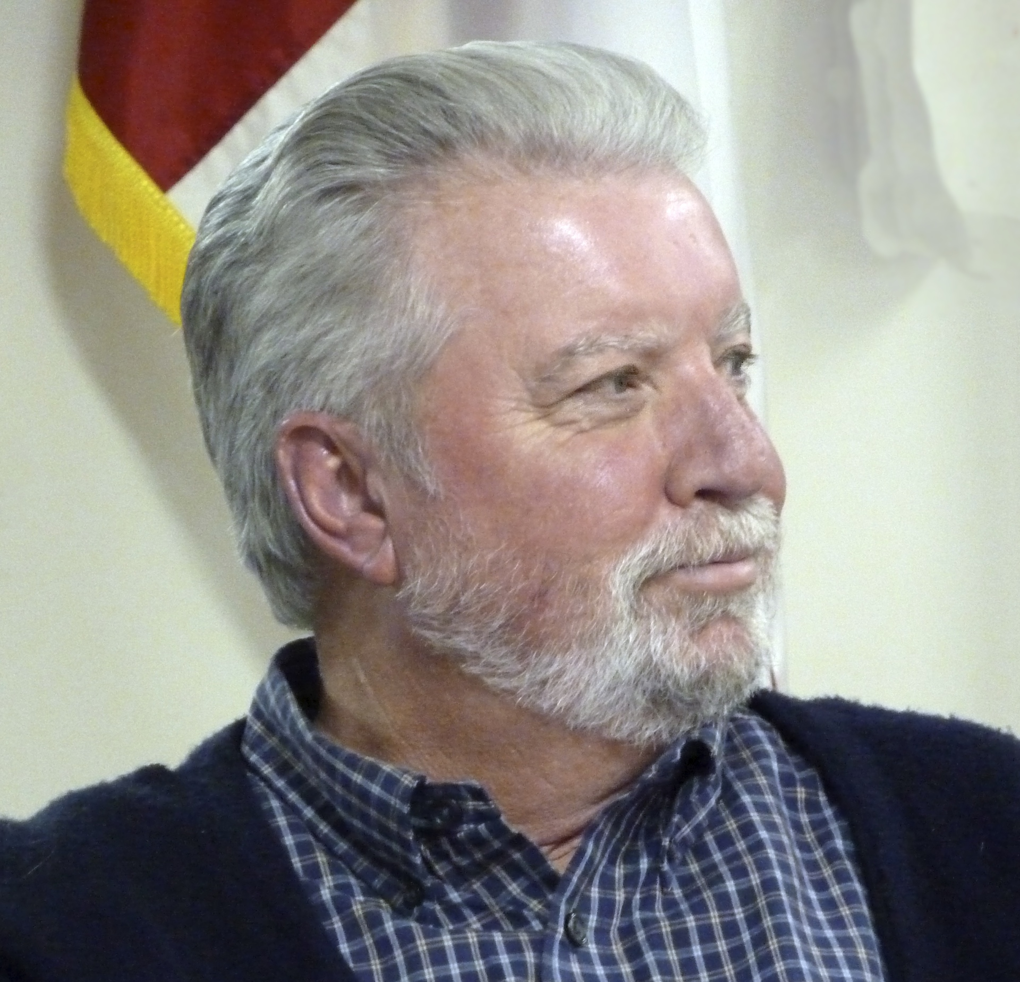
From the President:
Steve Miles

Hello everybody! Hope all of you are enjoying your water activities on our beautiful Lake Mitchell. I really enjoyed seeing everyone who made it to the Poker Run and the Picnic. We all enjoyed great fellowship and of course great food. I think the band is a big hit at our annual picnic. Thank you Johnye and Jim Woodrow for all your help with the picnic and to Rose Green and Rebecca Beaty for your help with the Poker Run. I would also like say what a great job Rebecca and her Scholarship team did in selecting two new HOBO Scholarship winners, Kelly Garrett and Drake Jones. The scholarship team did HOBO proud.

At this time there are no updates on the Rough Hornsnail but we will have an Area Rep. Meeting very soon and we will have some new info/ updates by then. As l close, just a reminder…you can like us on Facebook and check out some of the happenings on Lake Mitchell. Enjoy your summer and l will see you on the water.

Be Safe!!
Steve

HOBO Scholarship Report: Announcing 2016 Lake Mitchell HOBO Scholarship Winners
By Rebecca Beaty
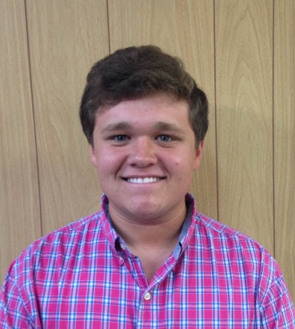
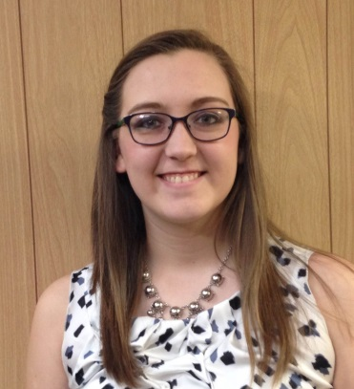
Lake Mitchell HOBO is pleased to announce that Drake Jones and Kelly Garrett are the 2016 scholarship winners. Each winner was awarded $2,000. Drake is a 2016 graduate of Chilton County High School. He will be attending the University of Montevallo where he will major in biology. He plans to become a teacher. Kelly graduated from Jemison High School and will be attending the University of Montevallo. She will pursue a degree in nursing.
Drake Jones Kelly Garrett

Thanks to all of you who have helped support our scholarship program through your donations, taking part in the Poker Run, participating in our photo contests to create annual Lake Mitchell calendars, and by purchasing those calendars

Now in its 16th year, this project provides a way of being good neighbors to those who live in the counties that border the beautiful lake we share.

Visit this website to Download New Alabama Boating Rules
We have new Water Patrol officers on our Lake. Be prepared!

http://www.outdooralabama.com/boating-rules-and-regulations
Alabama Marine Patrol HQ: 334-517-2950 or toll-free: 800-272-7930

HOBO Swap Shop:

For Sale by Judy Murchison at 205-755-0521 or 205-408-7445

Pink ladies Schwinn bike: $50.00 Sport Port Docking System $100.00
Red men's speed bike: $40.00

AREA REPRESENTATIVES
Area |  | Area Name | Representative | Phone
1 | Blue Creek/  The Ridge |  | Bobby Lewis  docx2@mindspring.com | 205-212-1020  205-901-8307
2 | Blue to Cargile |  | Jim & Johnye Woodrow  ajwking@aol.com | 205-425-9431  205-755-0055
3 | Cargile South |  | Dan Murchison  DanMurchison@gmail.com | 205-408-7445
4 | Cargile North |  | Connie Hampton connie28fan@yahoo.com  Susan Orr soriii@bellsouth.net | 205-755-6344  334-312-6131
5 | Cargile to Bird |  | Sonny & Peggy Bullard  pnsbullard@gmail.com | 205 -755-9514
6 | Bird Creek |  | Leslie Miles  lesliemiles0@gmail.com | 205-755-6432  205-612-2172
7 | Bird to Walnut |  | Becki & Mau McCallum  beckmau@gmail.com | 205 -755-5334
8 | Walnut SW |  | Beau Battaglia  beauredsox@yahoo.com | 504-909-6990
9 | Walnut Creek Peninsula |  | Betty & Joel Elam  Betty687@aol.com | 205-807-9056  205 -755-2775
10 | Cove and Mountain |  | Roxanne Martin  roxypmartin@gmail.com | 205 -755-0863
11 | Mountain to Lay Dam |  | Stan Holt  Stan-holt@att.net | 205-980-1428
12 | Upper Hatchet and Weogufka |  | VACANT
13A | East Pennamotley |  | Jim & Wathan Hand  jmhand@centurylink.net | 256-377-1153
13B | West Pennamotley |  | Richard & Wendy Cruse  wendycruse@gmail.com | 205-253-8298
14 | Hatchet to Big Airplane |  | Eric & Rose Green  rosegreenlake14@yahoo.com | 205-492-7151
15 | Airplane/Finger to Big Y Slough |  | Tommy Carpenter  rtcarpen@southernco.com | 256-377-1046  205-586-1749
16 | Big Y to Mitchell Dam |  | Nan & David Spivey  davidaspivey@gmail.com  nanspivey@gmail.com | 256-377-1178  205-492-0375

Mark Your Calendars!
Sunday, August 21 Area Rep Meeting Lake Mitchell Marina 1:00 PM Eat 2:00 PM Meet
Saturday, October 29 Renew Our Rivers Clean-up Higgins Ferry 8:00 AM
Friday, November 4 Annual Meeting Alabama Power Building 6:00 PM

Area Representative Reports:

Area 6-Bird Creek Leslie Miles
I want to congratulate Robin Cagle, a long time resident on Bird Creek, upon her retirement from 32 years of service in the Chilton County school system where she served as vice principal and principal. I know her co-workers and students will miss her dearly! But, now she will be able to spend more time with her family, especially now expecting a new granddaughter in October. Speaking of granddaughters, Steve and I are expecting our first grandchild this August! 4th generation of our family here on Lake Mitchell!!! I want to thank all the participants for the poker run and our annual picnic; it was a great success and a lot of fun! If you missed it I'm sorry cause we had a blast! Hope everyone has a safe and fun summer!

Area 15- Airplane/Finger to Big Y Slough-Tommy Carpenter

I hope everyone had a great time on Memorial Day. As always, boating safety should be at the forefront of our minds and remember to have all the items in your boat to make it safe and legal if water patrol decides to pay you a “visit”. I missed the picnic and poker run but it was for all the right reasons. My daughter (Bailey) got married that weekend to my new son-in-law Andrew Dickson. The last thing they said to me before they left for honeymoon was that as soon as they get back and get settled they want to come to the lake. I think you will see two new names in the next HOBO phone book. Andrew and Bailey Dickson. I am sure we will see them on the lake for the fireworks and BBQ if not before.
Recently, someone in Area 15 contacted me about getting a 911 address. After a few Emails and phone calls I realized that there could be some confusion between a 911 address to reach your cabin by LAND and the HOBO boat house signs to locate your property by WATER. Here is what you do if your property is on the Coosa County side and need emergency help from responders on LAND. First, you must contact the 911 Director in Rockford and get your “911” address. The 911 Director is Amanda Robinson at (256) 377-1911. Her cell number is (256) 391-2080. Amanda said for $20 they could make you a nice sign with the first three digits of your address. The sign is reflective and will help responders find you property day or night. I encourage everyone to get a sign and mark your driveway. Just a few minutes could make a big difference in some cases. Jim Woodrow is writing an article on the boathouse signs that you can obtain from HOBO. I know a little of the history but Jim is much more knowledgeable than I am and can explain boat house signs much better than I can.
As always, watch out for your neighbors. If you see something that does not look right, give them a call. That is a good thing!!! Remember we all have “HOBO” phone books so let’s use them. It also contains the number for Coosa county sheriff’s office and many others.
BE SAFE,
Tommy Carpenter
rtcriver@gmail.com

Alabama Power Shoreline Management

The Alabama Power Shoreline Management Team strives to protect and enhance the scenic, recreational and environmental values of the reservoirs it manages. As part of its mission, Alabama Power Shoreline Management is dedicated to ensuring all of the structures along Lake Mitchell’s shoreline comply with the shoreline management program developed by Alabama Power with the input of its local, state and federal regulatory partners.

Permits for shoreline construction are good for one year, and the program’s general policies are:
1. Alabama Power encourages shoreline structure owners to maintain the upkeep of existing boathouses, docks and seawalls. Prior to beginning any maintenance, contact Alabama Power to obtain a no-fee permit for repairs.
2. Alabama Power also encourages shoreline structure owners to remove noncompliant structures and replace them with compliant structures, and upon doing so will be issued a no-fee permit (e.g. replace an enclosed boathouse with an open boathouse).
3. A permit to build any new shoreline structure will incur a one-time $250 fee (e.g. new boathouse, new dock or new seawall). More than one activity may be authorized with a single permit.
Please call Alabama Power Shoreline Management Team Member Candy Hayes at 205-280-4476 to discuss your project/work and to obtain a permit prior to beginning any maintenance or construction.
P.O. Box 1324
Clanton, Alabama 35046 PAID Permit 12
Change Service Requested Birmingham, AL

Lake Mitchell H.O.B.O. Membership Application
Annual Dues  Homeowner  $25.00 | Marine 9 - Donation  Maintenance & Operation  $ |  |  |  | Fireworks - Donation  Purchase of Fireworks  $
Other Donation
Boathouse Sign $15____ Memorial ____ Education Fund ____ Scholarship _____ Other (specify) __________________

Amount $
Name: |  |  | Check  One: Renewal New Member
Home Mailing
Address:

Lake 911  Address: |  |  |  |  |  | Lake Area:
Email:

Home Phone: |  | Lake Phone: |  | Cell Phone
Detach and mail completed form along with your check to: Lake Mitchell H.O.B.O., PO Box 1324, Clanton, Al 35046

