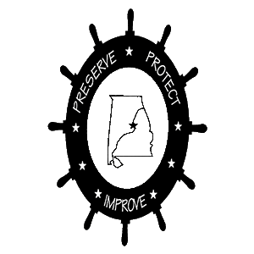
Lake Mitchell HOBO. | P.O. Box 1324 | Clanton, AL 35046

https://lakemitchellhobo.org

REMINDER FROM LAKE MITCHELL HOBO

Dear

We notice that you have not paid your dues this year for membership in the Lake Mitchell Home Owners and Boat Owners Association (HOBO). We hope this is just an oversight and we encourage you to send in your dues today, either via the enclosed membership form, which you can complete and mail along with your check, or, if you prefer, you can join and pay online from our website at https://lakemithchellhobo.org.

Our mission statement is broadly defined and designed to Preserve, Protect, and Improve Life on Lake Mitchell for all of our residents and visitors to our lake. To achieve our mission, we need the support of the entire lake community. Enclosed is a list of the many activities and accomplishments of Lake Mitchell HOBO that your membership dues and donations support.

Another valuable resource for comprehensive information about Lake Mitchell and HOBO is our website at https://lakemitchellhobo.org where you can find the following:

- Learn who is your HOBO Area Representative and who are our current officers.
- Check the calendar of HOBO events.
- Read the Alabama Power shoreline permitting rules before you do shoreline construction
- See photos from the many HOBO Activities
- Search the archive of old HOBO newsletters

You can even submit questions and suggestions from our website. You can also submit your lake photos to be published on the website.

We look forward to hearing from you soon and re-instating your Lake Mitchell HOBO membership.

Thank you!

