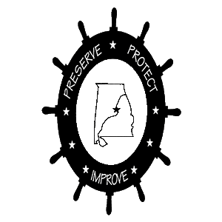
Lake Mitchell HOBO. | P.O. Box 1324 | Clanton, AL 35046

https://lakemitchellhobo.org

WELCOME TO LAKE MITCHELL HOBO!

Dear

We cordially invite you to join our fun crowd and become a member of Lake Mitchell Home Owners and Boat Owners Association (HOBO).

Enclosed is a list of many activities and accomplishments of Lake Mitchell HOBO. You can get a pretty good idea of what we do from this list.

Our mission statement is broadly defined and designed to Preserve, Protect, and Improve Life on Lake Mitchell for all of our residents and visitors to our lake.

We have divided our Lake into 16 areas with a HOBO Area Representative serving in each of our areas. Your Area Rep's job is to be your liaison to our Board of Directors with suggestions and questions as to how we can serve you best.

As a member of HOBO you will receive a welcome package and a complete lake telephone book of all our Lake Residents. This directory gives important emergency contact information as well as that of your lake neighbors.

For more information about Lake Mitchell and HOBO, please visit our website where you can find the following and much more!

- Learn who is your HOBO Area Representative and who are our current officers.
- Check the calendar of HOBO events.
- Read the Alabama Power shoreline permitting rules before you do shoreline construction
- See photos from the many HOBO Activities
- Search the archive of old HOBO newsletters

You can submit questions and suggestions from our website. You can also enter your lake photos to be published on the website.

To join HOBO, you can complete the enclosed application form and mail your application along with your check, or you can join and pay online via our website.

https://lakemitchellhobo.org

FROM ALL OF OUR HOBO FAMILY, WE GIVE YOU A BIG WELCOME ABOARD!

